Chapter 11.00C

Physical Problem for Fast Fourier Transform

Civil Engineering

Introduction

In this chapter, applications of FFT algorithms [1-5] for solving real-life problems such as computing the dynamical (displacement) response [6-7] of single degree of freedom (SDOF) water tower structure will be demonstrated.

Free Vibration Response of Single Degree-Of- Freedom, (SDOF) Systems

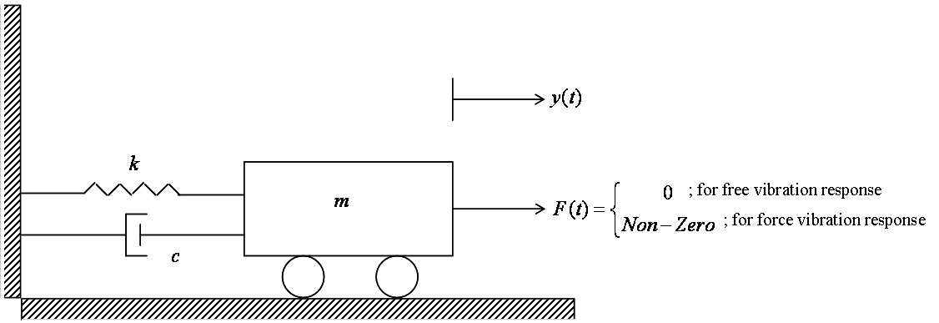
Figure 1 SDOF dynamic (water tower structure) system.

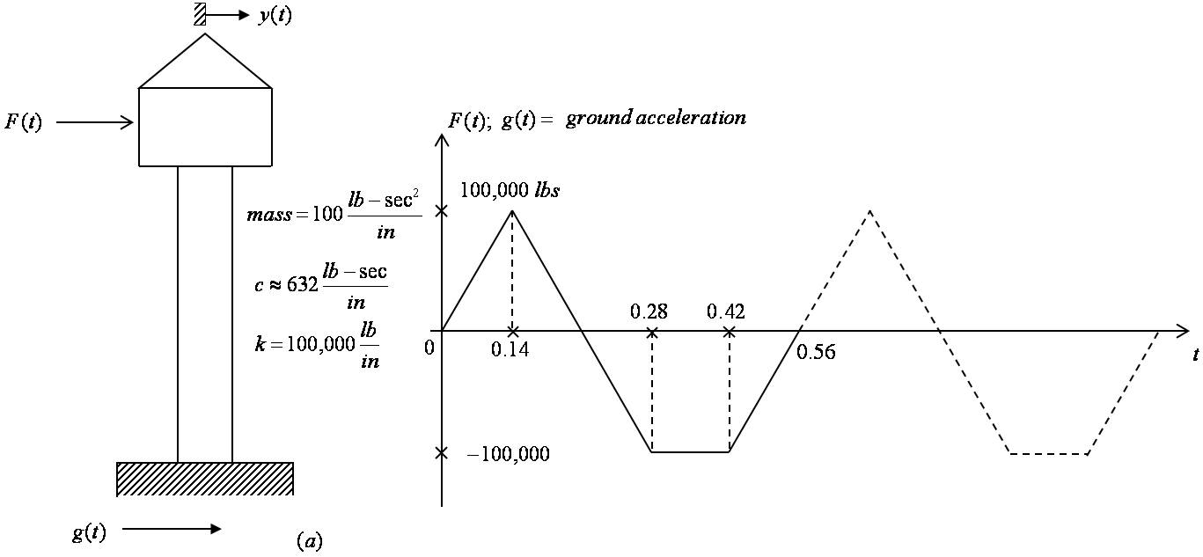
Figure 2 Water tower structure subjected to dynamic loads.

- Water tower structure, Idealized as SDOF system.
- Impulse blast loading 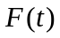, or earthquake ground acceleration 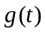.
The dynamical equilibrium for a SDOF system (shown in Figure 1) can be given as:
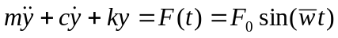 (1)
where
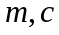 and 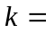mass, damping and spring stiffness, respectively (which are related to inertia, damping and spring forces, respectively).
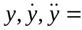 displacement, velocity, and acceleration, respectively.
Practical structural models such as the water tower structure subjected to applied blast loading (or earthquake ground acceleration) etc. can be conveniently modeled and studied as a simple SDOF system (shown in Figure 2).
For free vibration response, Equation (1) simplifies to
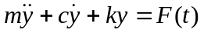 (2)
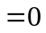
The solution (displacement response ) of Equation (2) can be expressed as
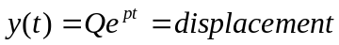 (3)
Hence
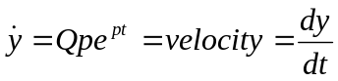 (4)
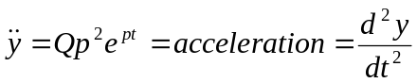 (5)
Substituting Equations (3-5) into Equation (2), one obtains
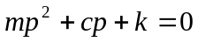 (6)
The two roots of the above quadratic equation can be obtained as

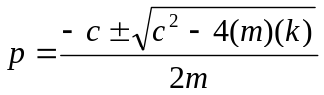 (7)
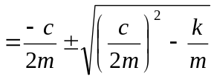 (8)

Critical Damping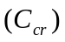
In this case, the term under the square root in Equation (8) is set to be zero, hence
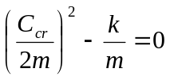 (9)
or
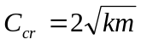 (10)
since
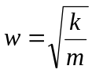 (11)
Hence
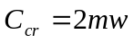 (12)
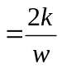
The two identical roots of Equation (8) can be computed as
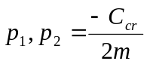 (13)
and the solution 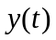 in Equation (3) can be given as
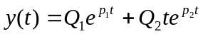 (14)
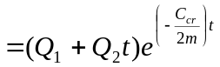 (15)
which can be plotted as shown in Figure 3.
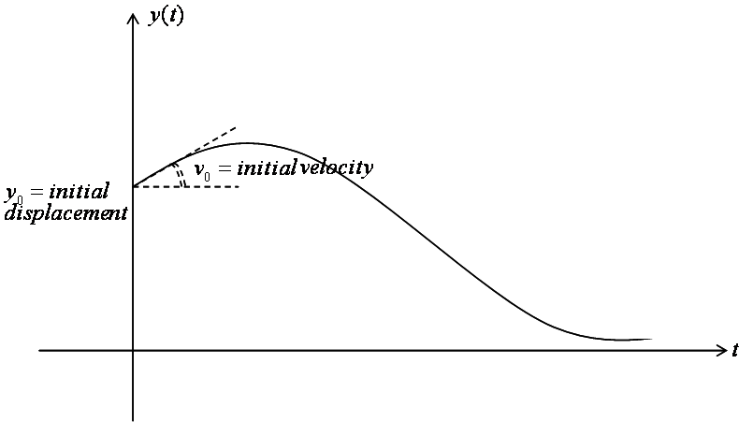
Figure 3 Free vibration with critical damping.

Over damping 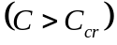
In this case, one has
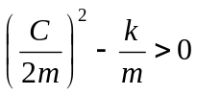 (16)
The solution of 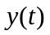 from Equation (3) can be given as
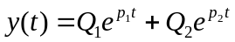 (17)
The response of over damping system is similar to Figure 3.

Under Damping 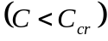
In this case, one has
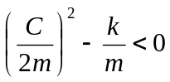 (18)
and the two “complex” roots from Equation (8) can be given as
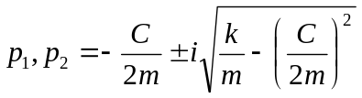 (19)
Substituting Equation (19), and using Euler’s equation 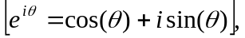 Equation (3) or Equation (17) becomes
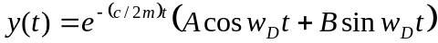 (20)
where
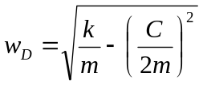 see Equation (19) (21)
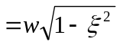 (22)
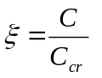
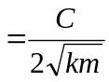 (23)
Using the initial conditions:
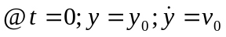 (24)
Then, the two constants ( and ) can be solved, and Equation (20) becomes
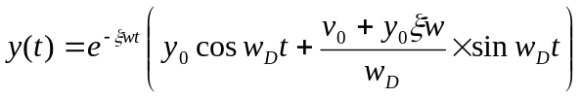 (25)
Equation (11.216) can also be expressed as:
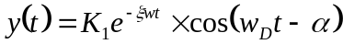 (26)
where
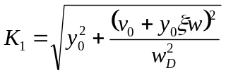 (27)
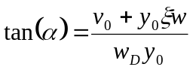 (28)
Equation (26) can be plotted as shown in Figure 4.

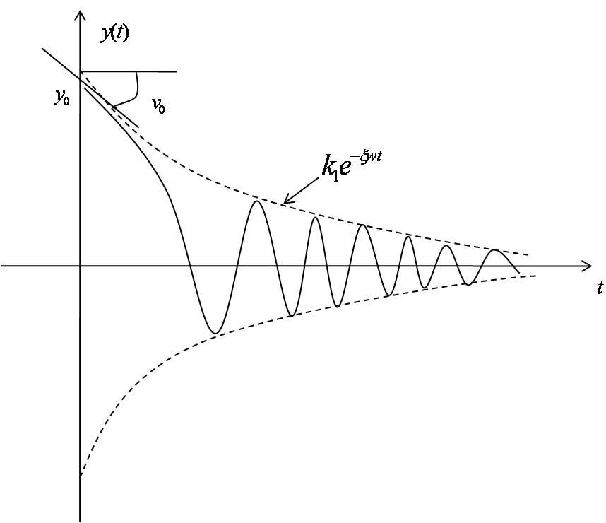 Figure 4 Free vibration of SDOF under damped system.

Force Vibration Response of SDOF Systems
For force vibration problem, the right-hand-side (RHS) of Equation (1) 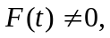and the general solution for Equation (1) can be given as
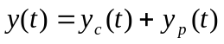 (29)
where the complimentary solution 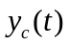 can be obtained as (see. Equation (20)) assumed under-damped 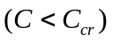 case
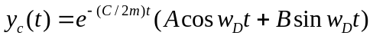 (20, repeated)
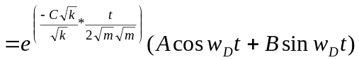
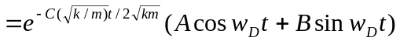 (30)
Using Equations (10) and (11), Equation (30) becomes
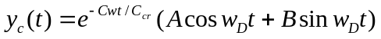
Using Equation (23), the above equation becomes
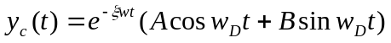 (31)

The particular solution 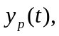 associated with the particular sine term forcing function 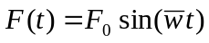 see Equation (1) can be given as
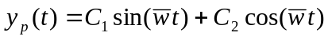 (32)
The unknown constants 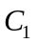 and 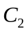 can be found by substituting Equation (32) into Equation (1), and equating the coefficients of the sine and cosine functions.

Using Euler’s identity, one has
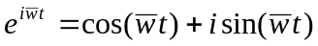 (33)
Thus, the RHS of Equation (1) can be expressed as
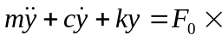 Imaginary portion of 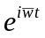 (34)
Hence, the response will consist of ONLY the imaginary portion of Equation (29).
The particular solution shown in Equation (32), can be more conveniently expressed as
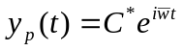 (35)
Substituting Equation (35) into Equation (34), one gets
(36)
or
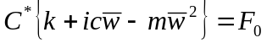 (37)
Hence
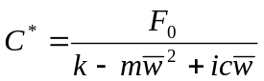 (38)
Substituting Equation (38) into Equation (35), one obtains
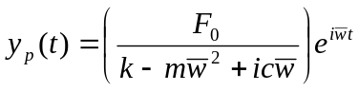 (39)
In Equation (39), the “complex” number
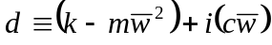 (40)
can be symbolically expressed as
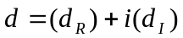 (41)
or in polar coordinates, one has (see Figure 5)
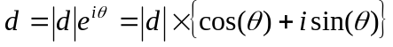 (42)
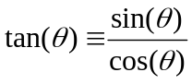 (43)
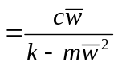
where
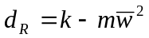 (44)
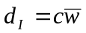 (45)
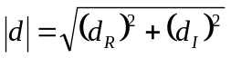 (46)
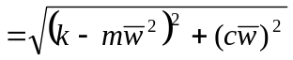 (47)
Thus, Equation (39) can be re-written as:
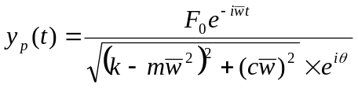 (48)
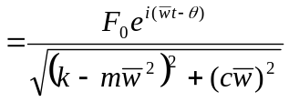 (49)

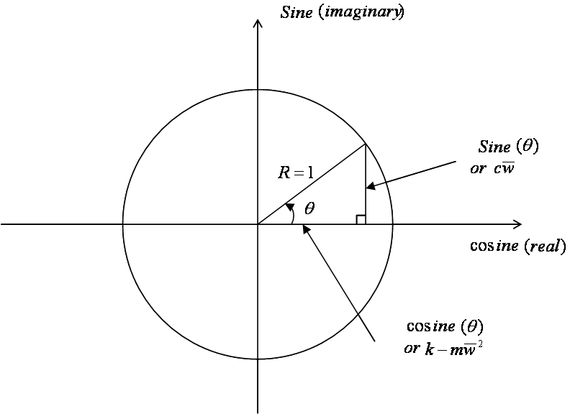
Figure 5 Polar coordinates.
The “imaginary” portion of Equation (49) can be given as
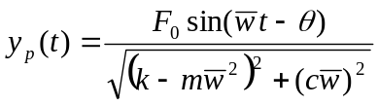 (50)
Define
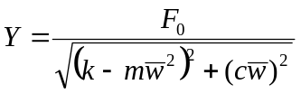= amplitude of the steady state motion (51)
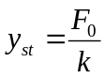= static deflection of a spring acted by the force 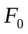 (52)
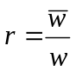= frequency ratio (of applied load/structure) (53)
Then, Equations (43) and (50) become
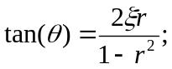 also refer to Equation (23) (54)
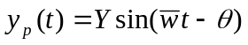 (55)
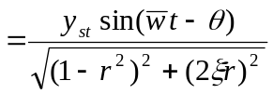 (56)
The complimentary (or transient) solution shown in Equation (31), and the particular solution 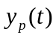 shown in Equation (56) can be substituted into the general solution (see Equation (29)) to obtain
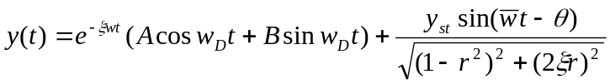 (57)
Define
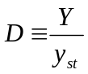 (58)
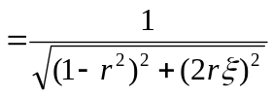
 = Dynamic Magnification Factor (59)

Dynamical Response by Fourier Series, DFT and FFT.
The dynamic load acting on the SDOF system can also be expressed in Fourier series as
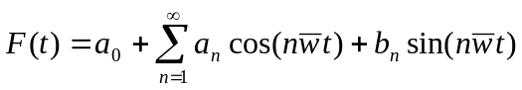 (60)
where the unknown Fourier coefficients can be computed as
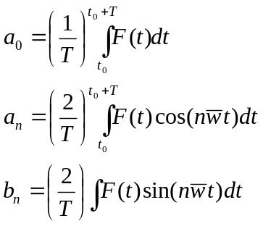 (61)
If the forcing function contains only sine terms, then the particular (steady state) solution can be found as (see Equation (56)):
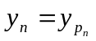 (62)
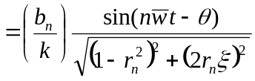
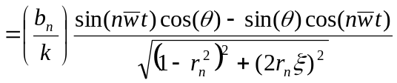 (63)
Recalled Equation (54), one has
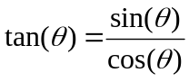
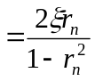
Hence
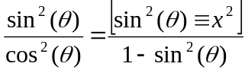 (64)
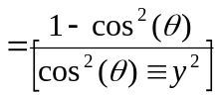
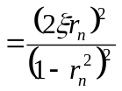
Solving Equation (64) for 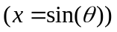 and 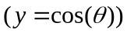, one gets
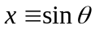
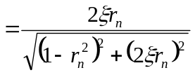
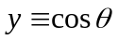 (65)
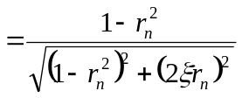
Substituting Equation (65) into Equation (63) to obtain:
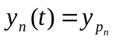 (66)
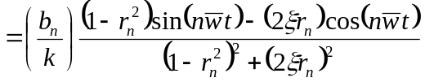
Similarly, if the forcing function contains only the cosine terms, then the particular (steady state) solution can be found as:
(67)
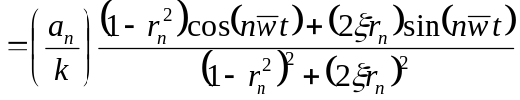
Finally, if the forcing function contains both sine and cosine terms, then the total response can be computed by combining both equations (66) and (67), including the constant forcing term 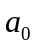, as following
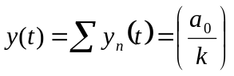 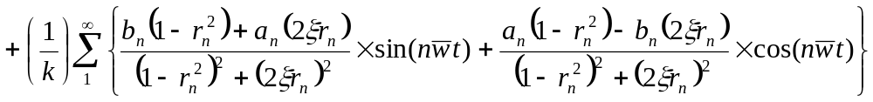 (68)

Remarks
Using Euler’s relationships, the dynamic load 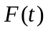 as shown in Equation (60), can also be expressed in exponential form as
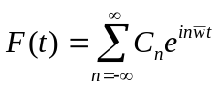 (18, Ch. 11.02)
where
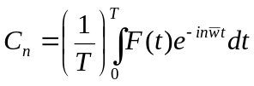 (20, Ch. 11.02)
For DFT, define
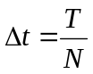 ; with 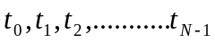 (69)

where
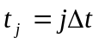 (70)
Then, the DFT pairs of Equations (21, 1, Ch. 11.04) becomes:
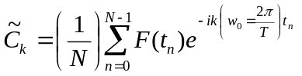
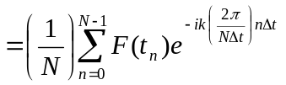
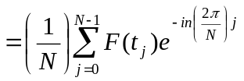; with 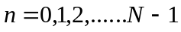 (71)
and
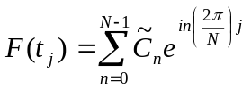; with 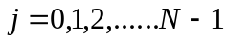 (72)
Since both Equations 71 and 72 do have similar operations, with the exceptions of the factor 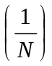and the sign 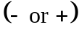of the exponential term, both these equations can be handled by the same “general_dft” program given at http://numericalmethods.eng.usf.edu/simulations/mtl/11fft/fft_civil_engg_example12.m

Introduce the unit amplitude exponential forcing function
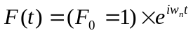 (73)
into RHS of Equation (1), the steady state solution can also be obtained as (see Equation 39):
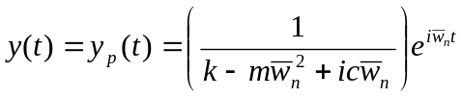 (39, repeated)
Using the notations defined in Equations (23) and (53), the above equation can be written as, for a harmonic force component of amplitude 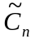.
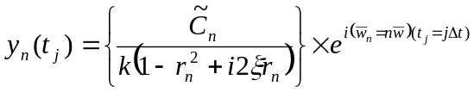
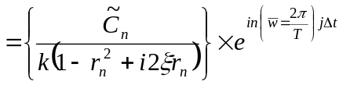
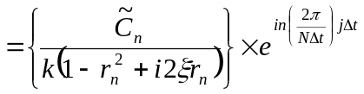
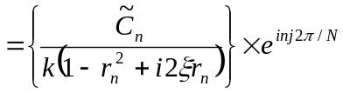 (74)
and the total (steady state) response due to “” harmonic force components can be calculated as
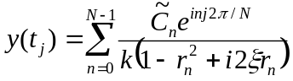 (75)

Dynamic Response of “Water Tank Structure” by FFT.
The dynamic response 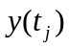in frequency domain of a general SDOF system (such as the “water tank structure”) can be obtained by Equation (75), and the required coefficients 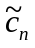 can be computed by Equation (71). Both of these equations can be represented (except for the sign), by the following general exponential function
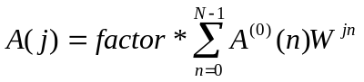 (76)
where
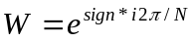 (77)
If Equation (71) needs be computed for , then one should define 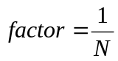, sign = -1, and 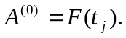 However, if Equation (75) needs be computed for 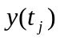, then one should define 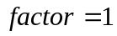, sign = +1, and 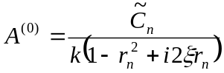.
It is important to notice that Equation (76) has the same form as shown in the earlier Equation (74). However, the definition of  in Equation (77) is different from the one shown in Equation (4, Ch. 11.05) by a negative sign in the power of . Therefore, efficient FFT subroutine (with user’s specified SIGN = 1, or -1) can be utilized, as given at http://numericalmethods.eng.usf.edu/simulations/mtl/11fft/fft_civil_engg_example12.m

References

[1] E.Oran Brigham, The Fast Fourier Transform, Prentice-Hall, Inc. (1974).

[2] S.C. Chapra, and R.P. Canale, Numerical Methods for Engineers, 4th Edition, Mc-Graw Hill (2002).

[3] W.H . Press, B.P. Flannery, S.A. Tenkolsky, and W.T. Vetterling, Numerical Recipies, Cambridge University Press (1989), Chapter 12.

[4] M.T. Heath, Scientific Computing, Mc-Graw Hill (1997).

[5] H. Joseph Weaver, Applications of Discrete and Continuous Fourier Analysis, John Wiley & Sons, Inc. (1983).

[6] Mario Paz, Structural Dynamics: Theory and Computation, 2nd Edition, Van Nostrand Inc. (1985).

[7] R.W. Clough, and J. Penzien, Dynamics of Structures, Mc-Graw Hill (1975).

